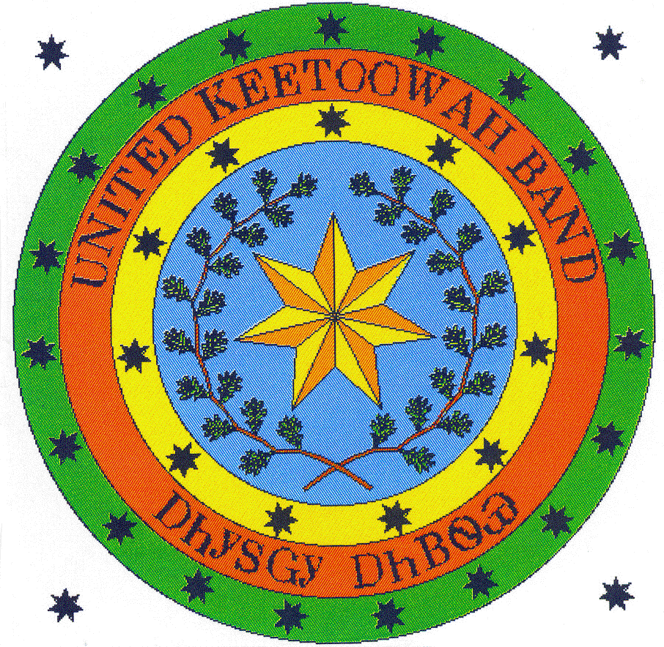
United Keetoowah Band of Cherokee Indians in Oklahoma
Spring Break Cultural Camp K-6 grades (12 & under)
March 16-20, 2015

Child Name:____________________________________ Home Phone No. _____________________________________
Address: _______________________________ City; ______________________________ State: ______Zip:__________
Tribal Membership: Keetoowah Cherokee Nation Other ___________________________
Date of Birth: _______________________________ Age: __________ Male Female
School: _____________________________City: ___________________ Grade: _______ UKB District: ______________

NAME OF PERSON TO CONTACT IN CASE OF EMERGENCY:

Name: ______________________________Relation: _______________ Day Phone: _____________________________
Name: ______________________________Relation: _______________ Day Phone: _____________________________

If you are not able to sign your child in/out, who has permission to do so in your absence?

Name: _____________________________ Relation: ________________Day Phone:___________________________
Name: _____________________________ Relation:_______________ Day Phone: ___________________________

Medical History: All information will remain confidential.

Family Physician: ___________________________________Phone: ___________________________________________
Address: __________________________________________City: ______________________ State: ______Zip:________

Health History:
Child requires the following regular medications or special diet:

Allergies and/or Conditions: _________________________________________________________________________

REGISTRATION AND ENROLLMENT AGREEMENT
- It is agreed that the $20.00 registration fee is a non-refundable donation.
- Campers and parents agree to abide by all rules set forth by the UKB JHCCM Camp Planning Team.
- The UKB JHCCM Camp is not responsible for the camper’s personal belongings, while at camp, if lost, damaged or otherwise destroyed. The camp will make every effort to provide supervision and keep losses at a minimum.
- The Director reserves the right to deny, cancel or suspend a child’s enrollment if deemed in the best interest of the campers or camp.
- UKB JHCCM reserves the right to use camper’s photo for promotional purposes in printed literature, videos and posted on UKB or JHCCM websites.
- Parent’s signature allows the Camp Director, Nurse, or Camp Staff to apply medical treatment for that which does not require emergency medical attention. Signature is consent for transportation in emergency vehicles if deemed necessary.
- Signature authorizes UKB JHCCM Camp as an agent to transport the enrolled child to and from a predetermined location, on tribal property and on field trip if applicable. The signature waives and releases any and all right s and claims that the camper may have against UKB JHCCM Day Camp and it representatives for any and all injuries suffered by the child in transit.

Parent’s Name: (Print) ________________________________________________________

Parent’s Signature: __________________________________________________________

Staff Initials: __________________ Date: ________________________________________ Registration fee: $ ______________________

Enrollment is not valid unless signed by a parent or guardian. Note: Enrollment is limited to first 50 completed and paid registrations.

